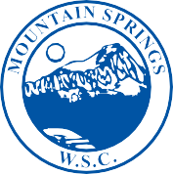

MOUNTAIN SPRINGS
WATER SUPPLY CORPORATION

NOTICE OF MEETING

Notice is hereby given that the Board of Directors of the Mountain Springs Water Supply Corporation will have their regular Monthly Meeting at Mountain Springs Water Supply Office, 7131 E. FM 922, Valley View, Texas. The meeting will be held Wednesday, December 14, 2022, at 7:00 p.m.

- Call Meeting to Order
- Public Forum – 3 Minutes Each
- Approve November Meeting Minutes
- Approve November Expenditures
- Manager’s Report
- Well Operator’s Report
- Old Business
Brandon Reason ~ Employment/Contract Services
- New Business
a. James Carrell ~ Will Serve to Rezone Property to Commercial
b. Employee Annual Bonus
- Executive Session
- Adjourn Meeting

P.O. Box 219 • 7131 E. FM 922 Valley View, Texas 76272
Phone 940-637-2219 • Fax 940-637-2531
mountainspringswatersupply.com

