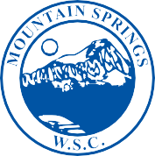

MOUNTAIN SPRINGS
WATER SUPPLY CORPORATION

NOTICE OF MEETING

Notice is hereby given that the Board of Directors of the Mountain Springs Water Supply Corporation will have their regular Monthly Meeting at 7131 E. FM 922, Valley View, Texas. The meeting will be held Wednesday, May 8, 2024, at 7:00 p.m.

- Call Meeting to Order
- Public Forum – 3 Minutes Each
- Approve April Meeting Minutes
- Approve April Expenditures
- Manager’s Report
- Well Operator’s Report
- Old Business
-Approve April, 2023 Annual Meeting Minutes
-2023 Audit by Rod Abbott
- New Business
-Muenster State bank CD 4.17% matures on 5/18/2024
- Executive Session
- Adjourn Meeting

P.O. Box 219 • 7131 E. FM 922 Valley View, Texas 76272
Phone 940-637-2219 • Fax 940-637-2531
mountainspringswatersupply.com

