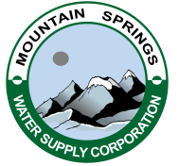

MOUNTAIN SPRINGS WATER SUPPLY CORPORATION
P.O. BOX 219 ~ VALLEY VIEW, TEXAS 76272

PHONE (940) 637-2219

NOTICE OF ANNUAL MEETING

Notice is hereby given that Mountain Springs Water Supply Corporation will have their Annual Meeting Thursday, April 4, 2019, at 7:00 p.m. at the Mountain Springs Community Building, Mt. Springs Road Valley View, Texas.

Barbecue Dinner and Door Prizes

AGENDA

- President Calls Meeting to Order
- Public Forum – 3 Minutes Each
- Last Call for Submission of Official Ballots
- Announce Total Members Present and Ballots Received
- Establishment of Quorum
- Approve 2018 Annual Meeting Minutes
- Financial Report & 2018 Annual Audit
- Corporation’s Operation Report
- Election Results
- Drawing for Door Prizes
- Adjourn Meeting

