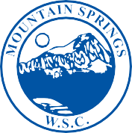

MOUNTAIN SPRINGS
WATER SUPPLY CORPORATION

NOTICE OF MEETING

Notice is hereby given that the Board of Directors of the Mountain Springs Water Supply Corporation will have their regular Monthly Meeting at Mountain Springs Water Supply Office, 7131 E. FM 922, Valley View, Texas. The meeting will be held Wednesday December 12, 2018, at 7:00 p.m.

- Call Meeting to Order
- Public Forum – 3 Minutes Each
- Approve October Meeting Minutes
- Approve October Expenditures
- Manager’s Report
- Well Operator’s Report
- Old Business
- New Business
A. Standard Leak Adjustments
(1.) Blakeney #28
(2.) McIntire #1054
B. Non-Standard Service Application – Knotted Oaks
- Executive Session
- Adjourn Meeting

P.O. Box 219 • 7131 E. FM 922 Valley View, Texas 76272
Phone 940-637-2219 • Fax 940-637-2531
mountainspringswatersupply.com

