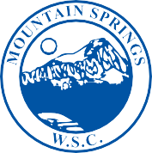

MOUNTAIN SPRINGS
WATER SUPPLY CORPORATION

NOTICE OF MEETING

Notice is hereby given that the Board of Directors of the Mountain Springs Water Supply Corporation will have their regular Monthly Meeting at the Mountain Springs Community Building, Mt. Springs Road Valley View. The meeting will be Thursday, April 4, 2019, following the 7:00 p.m. Annual Meeting

- Call Meeting to Order
- Public Forum – 3 Minutes Each
- Approve March Meeting Minutes
- Approve March Expenditures
- Manager’s Report
- Well Operator’s Report
- Old Business
- New Business
a. Leak Adjustment – Hodge #739
b. Establishment of Board Positions
- Executive Session
- Adjourn Meeting

P.O. Box 219 • 7131 E. FM 922 Valley View, Texas 76272
Phone 940-637-2219 • Fax 940-637-2531
mountainspringswatersupply.com

