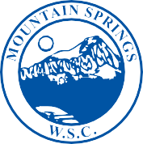

MOUNTAIN SPRINGS
WATER SUPPLY CORPORATION

NOTICE OF MEETING

Notice is hereby given that the Board of Directors of the Mountain Springs Water Supply Corporation will have their regular Monthly Meeting at Mountain Springs Water Supply Office, 7131 E. FM 922, Valley View, Texas. The meeting will be held Wednesday August 12, 2020, at 7:00 p.m.

- Call Meeting to Order
- Public Forum – 3 Minutes Each
- Approve July Meeting Minutes
- Approve July Expenditures
- Manager’s Report
- Well Operator’s Report
- Old Business
a. Cash Assets Diversification
b. Carport Bid
- New Business
Leak Adjustments – Kuykendall #318 & Nardizzi #735
- Executive Session
- Adjourn Meeting

P.O. Box 219 • 7131 E. FM 922
Valley View, Texas 76272
Phone 940-637-2219 • Fax 940-637-2531
mountainspringswatersupply.com

